NWL GHG INVENTORY DEFINTIONS (cite: CA Inventory glossary)

A
Activity Data
Data on the magnitude of a human activity resulting in emissions or removals taking place during a given period of time. Data on energy use, metal production, land areas, management systems, lime and fertilizer use and waste arisings are examples of activity data. (IPCC)
Additionality
Additionality represents the GHG removals or reductions that occur in addition to what would otherwise occur in a business-as-usual (BAU) scenario.
Afforestation
Planting of new forests on lands that historically have not contained forests. (IPCC2)
Air Pollutant
Any man-made and/or natural substance occurring in the atmosphere that may result in adverse effects to humans, animals, vegetation, and/or materials. (CARB)
Anthropogenic
The term "anthropogenic", in the context of greenhouse gas inventories, refers to greenhouse gas emissions and removals that are a direct result of human activities or are the result of natural processes that have been affected by human activities. (USEPA2)
Atmosphere
The gaseous envelope surrounding the Earth. The dry atmosphere consists almost entirely of nitrogen (78.1% volume mixing ratio) and oxygen (20.9% volume mixing ratio), together with a number of trace gases, such as argon (0.93% volume mixing ratio), helium and radiatively active greenhouse gases such as carbon dioxide (0.035% volume mixing ratio) and ozone. In addition, the atmosphere contains the greenhouse gas water vapor, whose amounts are highly variable but typically around 1% volume mixing ratio. The atmosphere also contains clouds and aerosols. (IPCC2)

B
Baseline Emissions
A baseline is a measurement, calculation, or time used as a basis for comparison. Baseline emissions are the level of emissions that would occur without policy intervention or without implementation of a project. Baseline estimates are needed to determine the effectiveness of emission reduction programs (also called mitigation strategies).
Base Year
The starting year for the inventory. Targets for reducing GHG emissions are often defined in relation to the base year.
Biomass
Either (1) the total mass of living organisms in a given area or of a given species usually expressed as dry weight; or (2) Organic matter consisting of or recently derived from living organisms (especially regarded as fuel) excluding peat. Includes products, by-products and waste derived from such material. (IPCC1)
Blue Carbon
Carbon stored in coastal and marine ecosystems including estuarine wetlands, submerged aquatic vegetation, and tidal mudflats.

C
Carbon Cycle
All parts (reservoirs) and fluxes of carbon. The cycle is usually thought of as four main reservoirs of carbon interconnected by pathways of exchange. The reservoirs are the atmosphere, terrestrial biosphere (usually includes freshwater systems), oceans, and sediments (includes fossil fuels). The annual movements of carbon, the carbon exchanges between reservoirs, occur because of various chemical, physical, geological, and biological processes. The ocean contains the largest pool of carbon near the surface of the Earth, but most of that pool is not involved with rapid exchange with the atmosphere. (NASA)
Carbon Credit (or offest)
A measurable, verifiable emission reduction that results from a certified offset project that reduces or avoids greenhouse gas (GHG) emissions and/or sequesters carbon.
Carbon Dioxide (CO₂)
A naturally occurring gas, and also a by-product of burning fossil fuels and biomass, as well as land-use changes and other industrial processes. It is the principal anthropogenic greenhouse gas that affects the Earth's radiative balance. It is the reference gas against which other greenhouse gases are measured and therefore has a Global Warming Potential of 1. (IPCC2)\
Carbon Dioxide Equivalent (CO₂e)
A metric used to compare emissions of various greenhouse gases. It is the mass of carbon dioxide that would produce the same estimated radiative forcing as a given mass of another greenhouse gas. Carbon dioxide equivalents are computed by multiplying the mass of the gas emitted by its global warming potential.
Carbon Equivalent (CE)
A metric measure used to compare the emissions of the different greenhouse gases based upon their global warming potential. Carbon equivalents can be calculated from to carbon dioxide equivalents by multiplying the carbon dioxide equivalents by 12/44 (the ratio of the molecular weight of carbon to that of carbon dioxide). The use of carbon equivalent is declining in GHG inventories.
Carbon Sequestration
This refers to the capture of CO₂ from the atmosphere and its long term storage in oceans (oceanic carbon sequestration), in biomass and soils (terrestrial carbon sequestration) or in underground reservoirs (geologic carbon sequestration).
Carbon Stock
Total volume of carbon stored in a carbon pool (e.g., biomass, soils). Typically reported as volume per unit area.
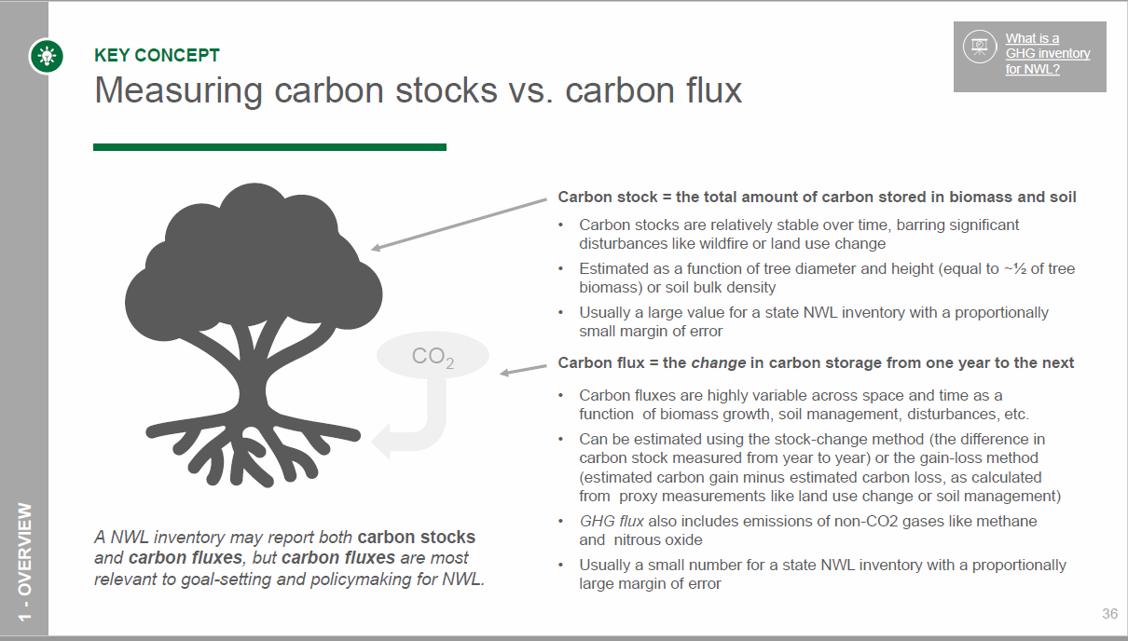
Consistency
Consistency means that an inventory should be internally consistent in all its elements over a period of years. An inventory is consistent if the same methodologies are used for the base and all subsequent years and if consistent data sets are used to estimate emissions or removals from sources or sinks. (IPCC)

D
Deforestation
Those practices or processes that result in the change of forested lands to non-forest uses. This is often cited as one of the major causes of the enhanced greenhouse effect for two reasons: 1) the burning or decomposition of the wood releases carbon dioxide; and 2) trees that once removed carbon dioxide from the atmosphere in the process of photosynthesis are no longer present and contributing to carbon storage. (UNFCC
Durability
The expected duration of carbon storage in a carbon pool; can also be expressed as the risk of reversal/loss of carbon storage due to anthropogenic or natural disturbances. Related to Permanence.

E
Emissions
The release of various gases, either from natural or anthropogenic sources, that results in increased atmospheric GHGs (e.g., carbon dioxide [CO2], methane [CH4], nitrous oxide [N2O]).
Emission Factor
A coefficient that quantifies the emissions or removals of a gas per unit activity. Emission factors are often based on a sample of measurement data, averaged to develop a representative rate of emission for a given activity level under a given set of operating conditions. (IPCC)
Emission Inventory
An estimate of the amount of pollutants emitted into the atmosphere from major mobile, stationary, area-wide, and natural source categories over a specific period of time such as a day or a year. (CARB)
Emission Rate
The weight of a pollutant emitted per unit of time (e.g., tons / year). (CARB)
Estimation
Estimation is the assessment of the value of an unmeasurable quantity using available data and knowledge within stated computational formulas or mathematical models.

F
Flux
Either (1) Raw materials, such as limestone, dolomite, lime, and silica sand, which are used to reduce the heat or other energy requirements of thermal processing of minerals (such as the smelting of metals). Fluxes also may serve a dual function as a slagging agent. (2) The rate of flow of any liquid or gas, across a given area; the amount of this crossing a given area in a given time. (e.g., "Flux of CO2 absorbed by forests"). (IPCC)

G
Greenhouse Gas
Any gas that absorbs infrared radiation in the atmosphere. Greenhouse gases include, but are not limited to, water vapor, carbon dioxide (CO₂), methane (CH₄), nitrous oxide (N₂O), hydrochlorofluorocarbons (HCFCs), ozone (O₃), hydrofluorocarbons (HFCs), perfluorocarbons (PFCs), and sulfur hexafluoride (SF₆). (UNFCC
Greenhouse Gas Inventory
Greenhouse Gas Inventory is a process that accounts for all human-caused emissions and removals of greenhouse gases (GHG) associated with a specific entity (e.g., a country, a company). The inventory essentially acts as a climate change balance sheet, tracking the total volume of GHG emitted from sources like fossil fuel consumption and agricultural production alongside the volume of GHG removed by sequestration in plants and soils or through technological means. (WRI/USCA)

L
Land Use and Land Use Change
Land use refers to the total of arrangements, activities and inputs undertaken in a certain land cover type (a set of human actions). The term land use is also used in the sense of the social and economic purposes for which land is managed (e.g., grazing, timber extraction and conservation). Land use change refers to a change in the use or management of land by humans, which may lead to a change in land cover. Land cover and land use change may have an impact on the surface albedo, evapotranspiration, sources and sinks of greenhouse gases, or other properties of the climate system and may thus have a radiative forcing and/or other impacts on climate, locally or globally. (IPCC2)
LULUCF
Acronym for "Land Use, Land Use Change and Forestry", a category of activities in GHG inventories.

M
Methane (CH₄)
A hydrocarbon that is a greenhouse gas with a global warming potential most recently estimated at 25 times that of carbon dioxide (CO₂). Methane is produced through anaerobic (without oxygen) decomposition of waste in landfills, flooded rice fields, animal digestion, decomposition of animal wastes, production and distribution of natural gas and petroleum, coal production, and incomplete fossil fuel combustion. The GWP is from the IPCC's Fourth Assessment Report (AR4).
Metric Ton
The tonne (t) or metric ton, sometimes referred to as a metric tonne, is an international unit of mass. A metric ton is equal to a Megagram (Mg), 1000 kilograms, 2204.6 pounds, or 1.1023 short tons.
Million Metric Tons (MMT)
Common measurement used in GHG inventories. It is equal to a Teragram (Tg).
Model
A model is a quantitatively-based abstraction of a real-world situation which may simplify or neglect certain features to better focus on its more important elements. (IPCC)

N
Natural Sources
Non-manmade emission sources, including biological and geological sources, wildfires, and windblown dust. (CARB)
Nitrogen Fixation
Conversion of atmospheric nitrogen gas into forms useful to plants and other organisms by lightning, bacteria, and blue-green algae; it is part of the nitrogen cycle. (UNFCC)
Nitrogen Oxides (NO_{x})
Gases consisting of one molecule of nitrogen and varying numbers of oxygen molecules. Nitrogen oxides are produced in the emissions of vehicle exhausts and from power stations. In the atmosphere, nitrogen oxides can contribute to formation of photochemical ozone (smog), can impair visibility, and have health consequences; they are thus considered pollutants. (NASA)
Nitrous Oxide (N₂O)
A powerful greenhouse gas with a global warming potential of 298 times that of carbon dioxide (CO₂). Major sources of nitrous oxide include soil cultivation practices, especially the use of commercial and organic fertilizers, manure management, fossil fuel combustion, nitric acid production, and biomass burning. The GWP is from the IPCC's Fourth Assessment Report (AR4).
P
Photosynthesis
The process by which plants take carbon dioxide from the air (or bicarbonate in water) to build carbohydrates, releasing oxygen in the process. There are several pathways of photosynthesis with different responses to atmospheric carbon dioxide concentrations. (IPCC2)

R
Radiative Forcing
A change in the balance between incoming solar radiation and outgoing infrared (i.e., thermal) radiation. Without any radiative forcing, solar radiation coming to the Earth would continue to be approximately equal to the infrared radiation emitted from the Earth. The addition of greenhouse gases to the atmosphere traps an increased fraction of the infrared radiation, reradiating it back toward the surface of the Earth and thereby creates a warming influence. (UNFCC)
Reforestation
Planting of forests on lands that have previously contained forests but that have been converted to some other use. (IPCC2)
Regeneration
The act of renewing tree cover by establishing young trees, naturally or artificially - note regeneration usually maintains the same forest type and is done promptly after the previous stand or forest was removed. (CSU)
Respiration
The process whereby living organisms convert organic matter to carbon dioxide, releasing energy and consuming molecular oxygen. (IPCC2)

S
Short Ton
Common measurement for a ton in the United States. A short ton is equal to 2,000 lbs or 0.907 metric tons. (USEPA1)
Sink
Any process, activity or mechanism that removes a greenhouse gas, an aerosol or a precursor of a greenhouse gas or aerosol from the atmosphere. (IPCC2)
Source
Any process, activity or mechanism that releases a greenhouse gas, an aerosol or a precursor of a greenhouse gas or aerosol into the atmosphere. (IPCC2

T
Terrestrial Carbon Sequestration
It is the process through which carbon dioxide (CO₂) from the atmosphere is absorbed by trees, plants and crops through photosynthesis, and stored as carbon in biomass (tree trunks, branches, foliage and roots) and soils. The term "sinks" is also used to refer to forests, croplands, and grazing lands, and their ability to sequester carbon. Agriculture and forestry activities can also release CO₂ to the atmosphere. Therefore, a carbon sink occurs when carbon sequestration is greater than carbon releases over some time period. (USEPA3)
Total Organic Gases (TOG)
Gaseous organic compounds, including reactive organic gases and the relatively unreactive organic gases such as methane. (CARB)
Transparency
Transparency means that the assumptions and methodologies used for an inventory should be clearly explained to facilitate replication and assessment of the inventory by users of the reported information. The transparency of inventories is fundamental to the success of the process for the communication and consideration of information. (IPCC)
Trend
The trend of a quantity measures its change over a time period, with a positive trend value indicating growth in the quantity, and a negative value indicating a decrease. It is defined as the ratio of the change in the quantity over the time period, divided by the initial value of the quantity, and is usually expressed either as a percentage or a fraction. (IPCC)

